SPEECH TO TEXT USING NLP

END TERM REPORT
By
1. Name:-Satyam Kumar
Sec. :- K18SJ
Roll no. :- 10
Reg. No. :- 11802282
2. Name:-Anurag Bhardwaj
Sec. :- K18SJ
Roll no. :- 16
Reg. No. :- 11813051
3. Name:- Ashutosh Pandey
Sec. :- K18SJ
Roll no. : - 30
Reg. No. : - 11802186
Department of Intelligent Systems
School of Computer Science Engineering
Lovely Professional University, Jalandhar
SIGNATURE OF STUDENTS

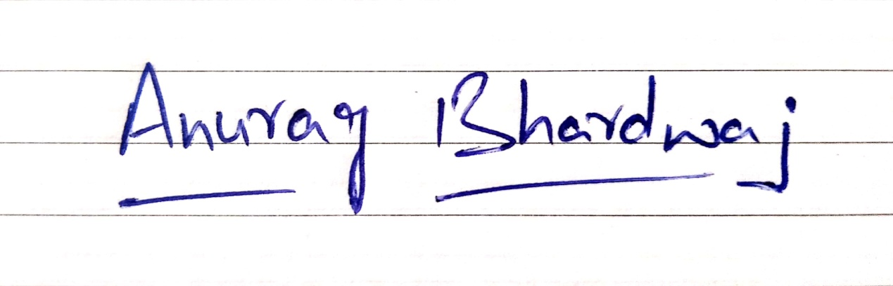
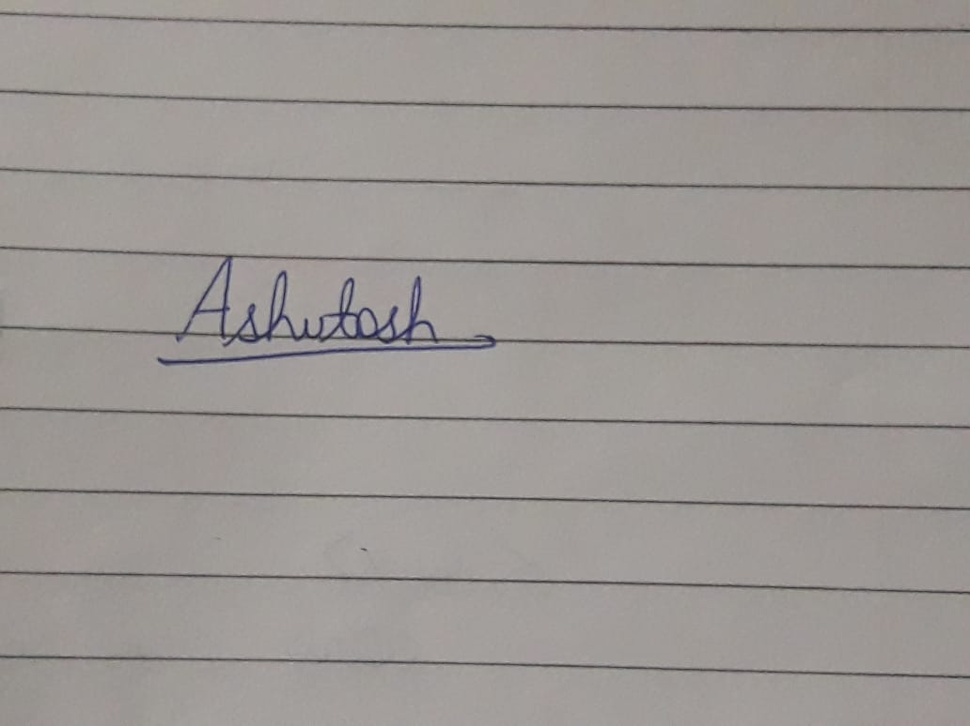

STUDENT DECLARATION

This is to declare that this report has been written by me/us. No part of the report is copied from other sources. All information included from other sources have been duly acknowledged. I/We aver that if any part of the report is found to be copied, I/we are shall take full responsibility for it.

1.Satyam Kumar
2.Anurag Bhardwaj
3. Ashutosh Pandey
TABLE OF CONTENTS

TITLE | PAGE NO.
- ARTIFICIAL INTELLIGENCE | 1-5
- DESCRIPTION OF PROJECT | 6-8
- APPLICATION DETAILS | 8-10
- SCREENSHOTS | 11-14

1.ARTIFICIAL INTELLIGENCE
“Artificial Intelligence is neither a new technology nor a machine”.Artificial intelligence (AI), the ability of a digital computer or computer-controlled robot to perform tasks commonly associated with intelligent beings. The term is frequently applied to the project of developing systems endowed with the intellectual processes characteristic of humans, such as the ability to reason, discover meaning, generalize, or learn from past experience. Since the development of the digital computer in the 1940s, it has been demonstrated that computers can be programmed to carry out very complex tasks—as, for example, discovering proofs for mathematical theorems or playing chess—with great proficiency. Still, despite continuing advances in computer processing speed and memory capacity, there are as yet no programs that can match human flexibility over wider domains or in tasks requiring much everyday knowledge. On the other hand, some programs have attained the performance levels of human experts and professionals in performing certain specific tasks, so that artificial intelligence in this limited sense is found in applications as diverse as medical diagnosis, computer search engines, and voice or handwriting recognition.

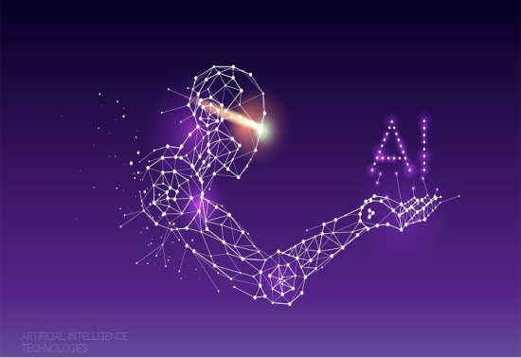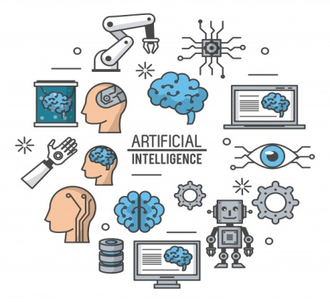

  - NATURAL LANGUAGE PROCESSING(NLP)

Natural Language Processing (NLP) is a subfield of Computer Science that deals with Artificial Intelligence (AI), which enables computers to understand and process human language.
It is the machine’s ability to process what was said, structure the information received, determine the necessary response and respond in a language that we understand.

The different phases of NLP are given as

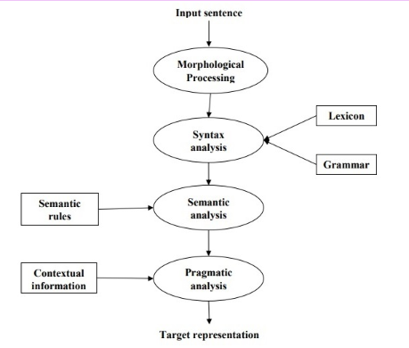
    - APPLICATIONS OF NLP

- MACHINE TRANSLATION
Everyone knows what is a manual translation — we translate information from one language into another. When the same thing is done by a machine, we deal with “Machine” Translation. The idea behind MT is simple — to develop computer algorithms to allow automatical translation without any human intervention. The best-known application is probably Google Translate.

- SPEECH RECOGNITION

NLP allowed to achieve significant success. Now we have a whole variety of speech recognition software programs that allow us to decode the human voice. It is a mobile telephony, home automation, hands-free computing, virtual assistance, video games, and etc.
For examples voice assistants (Cortana, Google Assistant, Siri, …) are the best example for the speech recognition.

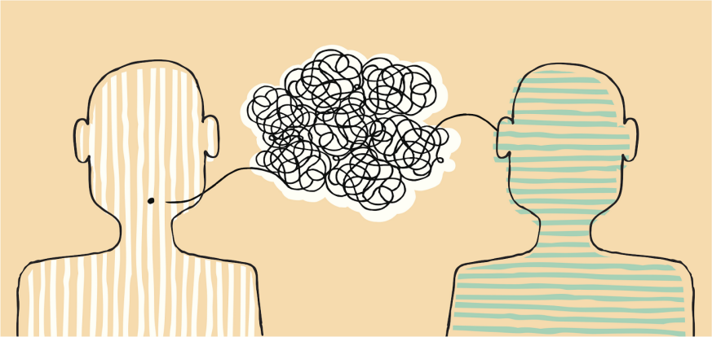

- SENTIMENTAL ANALYSIS

Sentiment analysis (also known as opinion mining or emotion AI) is an interesting type of data mining that measures the inclination of people’s opinions. The task of this analysis is to identify subjective information in the text. For example, this can be a movie review or an emotional state caused by this movie.

- CHATBOTS

The first chatbots appeared in the 1960s, they were quite primitive: they basically rephrased what person spoke to them. Modern chatbots are not far from their ancestors. NLP has become the basis for creating chatbots, and although such systems are not so perfect they easily can handle standard tasks. Chatbots currently operate on several channels, including the Internet, applications, and messaging platforms.

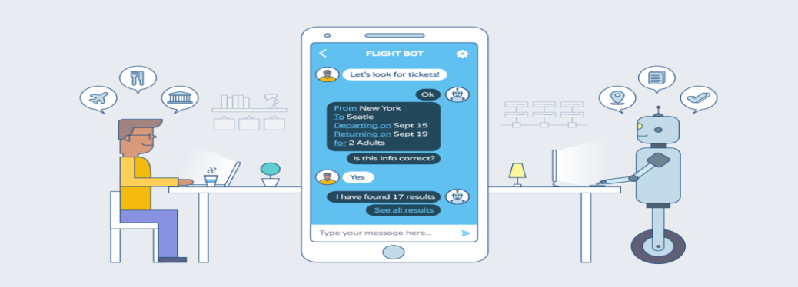



- CHARACTER RECOGNITION
Character Recognition systems also have numerous applications like receipt character recognition, invoice character recognition, check character recognition, legal billing document character recognition

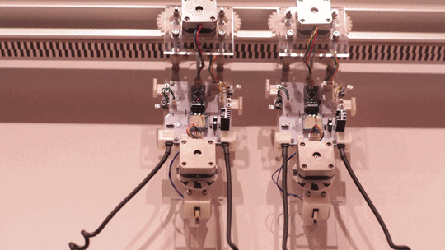

1.1.2 HOW DOES COMPUTER UNDERSTAND TEXT?

In a nutshell, the process of machine understanding using natural language processing algorithms looks like this:
- A person says something to the machine
2. The machine records sound.
3. The machine turns audio into text.
4. The NLP system parses the text into components, understands the context of the conversation and the intention of the person.
5. Based on the results of the NLP, the machine determines which command should be executed.
Some of the virtual assistants which are being used in the markets are as(siri,Google,bixbi etc).

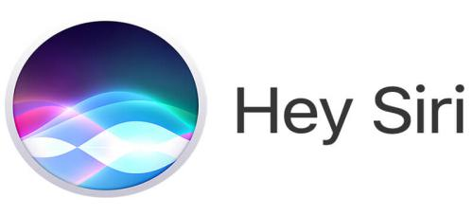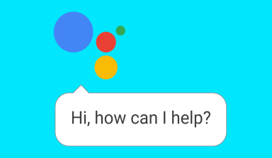

- DESCRIPTION OF PROJECT

  - DATA FLOW DIAGRAM

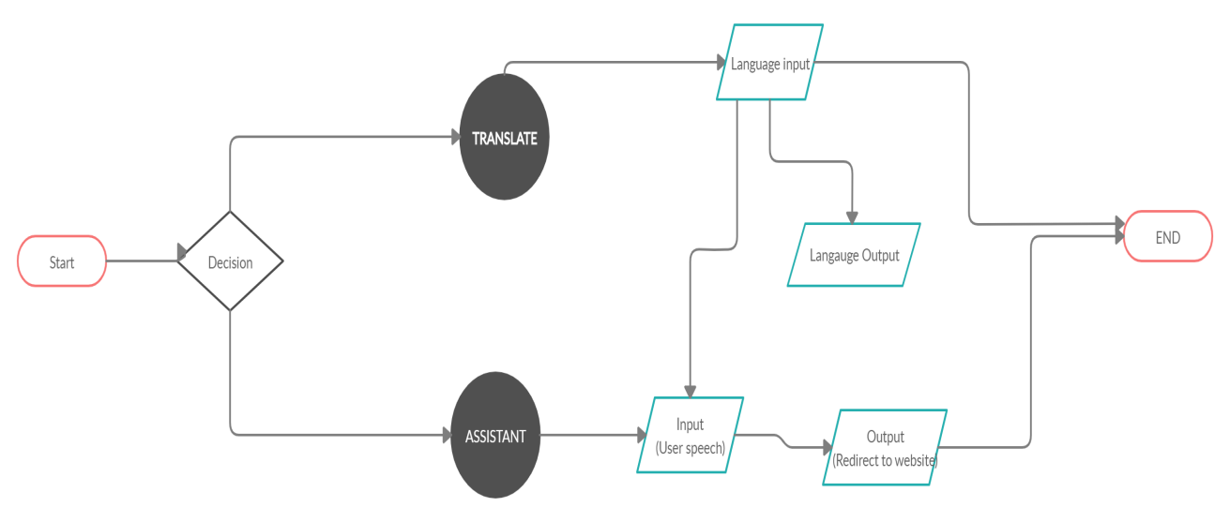

2.2 FUNCTIONAL AND NON-FUNCTIONAL REQUIREMENTS

Functional and Non-functional requirements are identified through the analysis of the data collected from the survey. Functional requirements are the features and functionality that the system must have or be able to perform whereas non-functional requirements define the manner or characteristic the system must have such as: performance, usability, modifiability, maintainability, security, scalability, reliability.

2.2.1 FUNCTIONAL REQUIREMENTS
- The application must be efficient with very little lag in response time.
- The application must be reliable with next to no faults or bugs.
- Provide text and audio responses.
- The application will assist users with their queries and carry out appropriate actions
- Users will be able to converse with the Chat bot through voice or text commands and it will understand what the user is saying through natural language processing provided through the integration of Dialogflow API

2.2.2 NON-FUNCTIONAL REQUIREMENTS
- The application must be reliable with next to no faults or bugs
- The use of natural language used to interact with the application promotes human computer interaction.
- The database must be scalable to adopt to a growing number of users.
- Provide accurate responses to input.

2.3 Software and Hardware Specification
The software and hardware requirements necessary to implement the chatbot are stated below.
2.3.1 SOFTWARE REQUIREMENTS
• Oracle VM VirtualBox
• IDLE python 3.6 or above
• Internet connection
• gtts
• pyaudio
• pi-image
• google translate
• Sublime Text 2
• Dialogflow

2.6.2 HARDWARE REQUIREMENTS
• PC running windows operating system
• Processor – intel core i5
• Android Device

- APPLICATION DETAILS

3.1INTRODUCTION
The application is using NLP feature for it’s most of the work. Here, in the application the user have choice to access to of the property
- ) Translate
- ) Search on the web.

3.1.1TRANSLATE
In this feature the user to allowed to speak in certain language which in return is converted into another set of language. For this the application is using modules like gtts, pyimage,pyaudio etc.

Input language | Output language
English | English
Hindi | Hindi
French | French

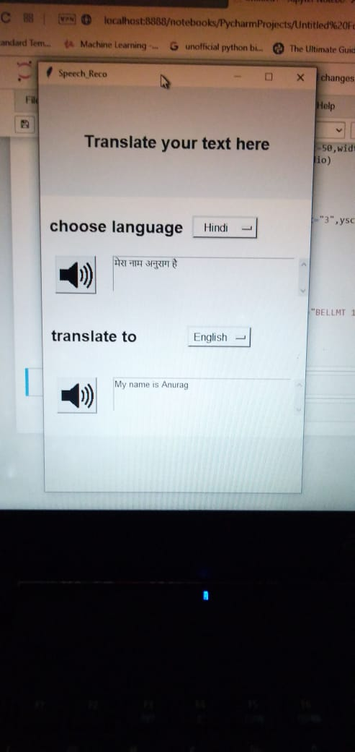

3.1.2 SEARCH THW WEB
Whenever the bot button on the application is being clicked, it provides user the best search option related to that particular term from www.google.com.
( Search result when it was asked to search LPU)
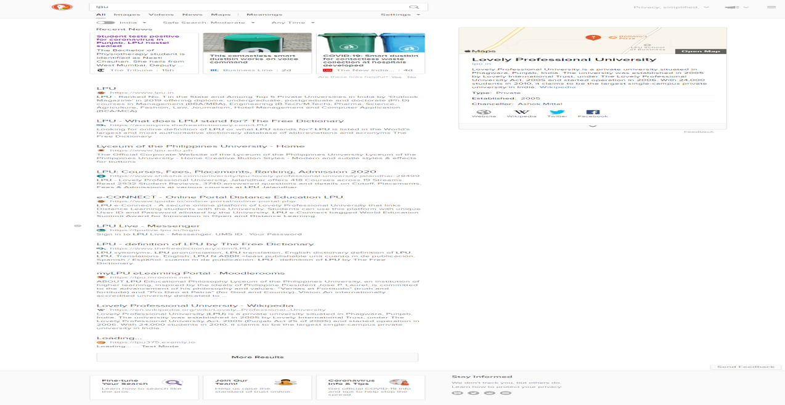

4 .SCREENSHOTS

